The Mixed Nuts
Set JJ Last revised on 2016.06.05
JJ01-This Could Be The Start Of Something Big(KVD).2016.06.05.pdf
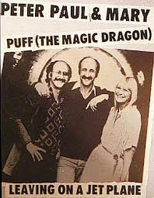
JJ01-This Could Be The Start Of Something Big(VOCAL DUET).2016.06.05.pdf
JJ02-Blue Skirt Waltz(KV).2015.04.24.pdf
JJ03-Kiss Of Fire(KVF)2016.02.15.pdf
JJ03-Kiss Of Fire(KVM)2016.02.15.pdf
JJ04-Sweet Sue - Just You(KV).2013.09.13.pdf
JJ05-The Man I Love(KV).2016.03.21.pdf
JJ06-Too Fat Polka(KV).pdf
JJ07-Stranger On The Shore(KVF).2016.03.21.pdf
JJ07-Stranger On The Shore(KVM).2016.03.21.pdf
JJ08-There'll Be Some Changes Made(KVF).2016.03.21.pdf
JJ08-There'll Be Some Changes Made(KVM).2016.03.21.pdf
JJ09-Puff, The Magic Dragon(KV).2014.04.26.pdf
JJ10-Leavin' On A Jet Plane(KVF).pdf
JJ10-Leavin' On A Jet Plane(KVM).pdf
JJ11-Blowin' In The Wind(KVD).2016.03.21.pdf
JJ12-I'll See You In My Dreams(KVF).2016.03.21.pdf
JJ12-I'll See You In My Dreams(KVM).2016.03.21.pdf
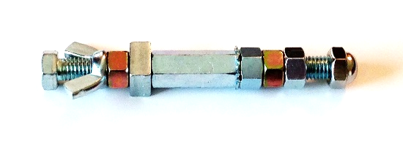
JJ13-Love Letters In The Sand(KVF).2016.06.05.pdf
JJ13-Love Letters In The Sand(KVM).2016.06.05.pdf
JJ14-We're In The Money(KVF).pdf
JJ14-We're In The Money(KVM).pdf
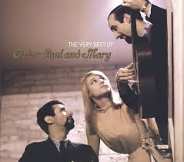
JJ15-When The Moon Comes Over The Mountain(KVF).pdf
JJ15-When The Moon Comes Over The Mountain(KVM).pdf
JJ16-East Of The Sun(KVF).pdf
JJ16-East Of The Sun(KVM).pdf
JJ17-Hucklebuck, The(KVF).2014.01.11.pdf
JJ17-Hucklebuck, The(KVM).2014.01.11.pdf

